Sustainable Pine Forests, the Paper & Packaging Industry, and What You Can Do to Help
Recently, I was reading about what the paper and packaging industry does to promote sustainable forests. According to the Paper and Packaging Industry publication, more than half of U.S. forestlands are owned and managed by about 11 million private individuals. Most importantly, more than 90% of U.S. forest products come from privately owned land.
Much of this land has been in the same family for many generations. This number includes numerous small, family owned tracts of land. The owners carefully steward the land year after year. They harvest some trees for the paper industry and then plant new trees to maintain a sustainable forest.
What is fascinating is that nearly twice as much timber is grown each year than is harvested in the U.S.! More than one billion trees are planted every year! In the last 30 years, forested areas have increased by nearly 33 million acres. Many of these acres include forests created from reclaimed lands that were clearcut generations ago for crops or pasturelands.
It is also interesting to note that paper can be recycled up to 7 times! According to the Paper and Packaging Industry, about 85% of trees used to make packaging paper and paperboard products in the southeast sector of our nation come from softwood conifers like loblolly pine. This conifer grows for 20 to 25 years, is harvested, and is replaced with new saplings.
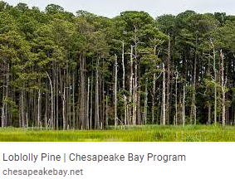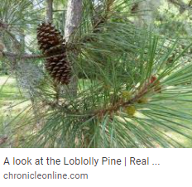
During the first twelve years of a pine forest’s growth, the trees provide a home to all types of song birds and small wildlife. As trees grow from 12 to 20 years of age, wild turkeys, foxes, opossums, raccoons, and skunks call these pine forests home. From 20 to 25 years of age, trees provide habitat for woodpeckers and deer. After 25 years, trees are harvested and new saplings planted. In this way, forest owners ensure that pine forests are always growing and that biodiversity is maintained.
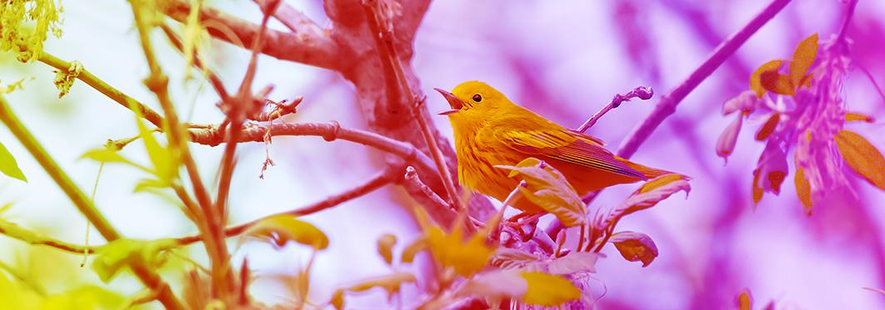
And did you know that paper and paper based products are the most recycled material in the U.S. The average recycling rate is over 92% for cardboard boxes. The overall recycling rate for paper in 2020 was over 65%.
In summary, please choose products packaged in paper and cardboard containers to encourage forest owners to plant more trees. When we choose paper products, we promote a healthy market for forest products. This in turn encourages forest owners to plant more trees!
And lastly, continue to recycle those paper products to practice good environmental stewardship!

Written by: Greg Petrosky
Date: December, 2021

