April 18, 2021 – Maple River
Leader: Don Burlett

It’s always good to get out on a nice spring day to bird. With the temperature starting in the upper 30’s and reaching the upper 50’s while blue skies prevailed, it was a good day. Then add a bunch of birds to that and it’s a great mix. 10 birders enjoyed a nice walk around the impoundments at Maple River looking for waterfowl and other early migrants. Lots of duck species to find along with a handful of shorebirds, raptors and some passerines.

The highlight of the day was the flyover of 22 American White Pelicans. Graceful and armed with the “breeding knob” on the bills, they were a delight. It was also nice to see Northern Pintail along with the whole collection of ducks.

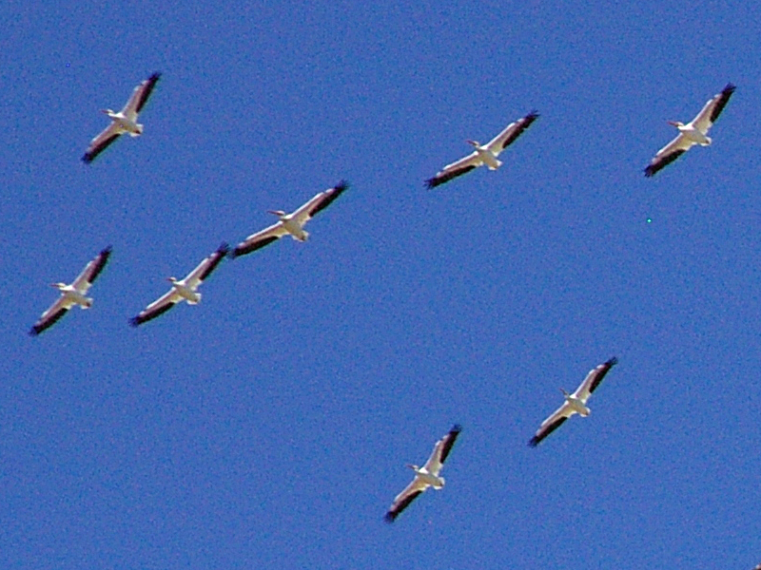

A complete list of species seen is provided below.

58 species seen

Canada Goose
Wood Duck
Blue-winged Teal
Northern Shoveler
Gadwall
American Wigeon
Mallard
Northern Pintail
Green-winged Teal
Bufflehead
Common Merganser
Ruddy Duck
Ring-necked Pheasant
Pied-billed Grebe
Mourning Dove
American Coot
Sandhill Crane
Killdeer
Pectoral Sandpiper
Wilson’s Snipe
Greater Yellowlegs
Lesser Yellowlegs
Ring-billed Gull
Herring Gull
Double-crested Cormorant
American White Pelican
Great Blue Heron
Turkey Vulture
Osprey
Northern Harrier
Bald Eagle
Red-tailed Hawk
Rough-legged Hawk
Belted Kingfisher
Red-bellied Woodpecker
Pileated Woodpecker
Northern Flicker
Eastern Phoebe
Black-capped Chickadee
Tufted Titmouse
Horned Lark
Tree Swallow
Barn Swallow
Blue Jay
White-breasted Nuthatch
European Starling
American Robin
American Goldfinch
Field Sparrow
American Tree Sparrow
Song Sparrow
Swamp Sparrow
Red-winged Blackbird
Brown-headed Cowbird
Rusty Blackbird
Common Grackle
Yellow-rumped Warbler

