The Invasive Spotted Lanternfly – It’s Here!
In December, 2020, I posted an article (scroll down through the “Conservation” tab of the Oakland Audubon Society website and please read that article) about the invasive Spotted Lanternfly (Lycorma delicatula). This plant hopper, about 1” long, is a native insect of China, Bangladesh, and Vietnam.
Much to my dismay, the Michigan Department of Agriculture and Rural Development (MDARD) just announced that a small population of spotted lanternflies have been found in Pontiac in Oakland County. See spotted lanternfly images below.
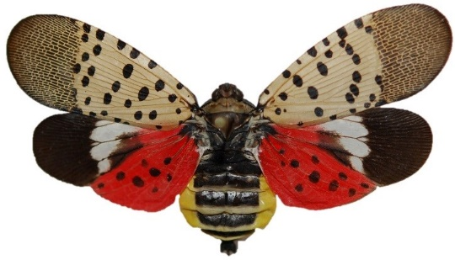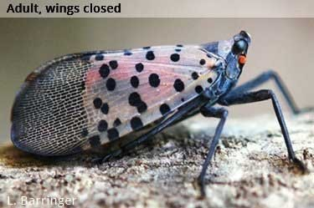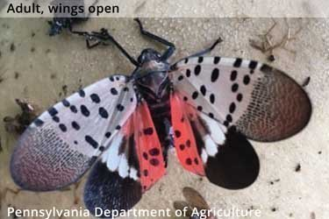
Mike Philip, MDARD”s Pesticide and Plant Pest Management Division Director speculates that the spotted lanternflies hitchhiked on nursery stock brought in from an already infected state. He suspects these invasive insects have been in Michigan for several months.
In my article of December, 2020, I wrote that spotted lanternflies, originally discovered in Pennsylvania in 2014, had migrated to the states of Delaware, Maryland, New Jersey, New York, and Virginia. Since then, new sightings of spotted lanternflies have been recorded in Connecticut, Indiana, Massachusetts, North Carolina, Ohio, and West Virginia. In just over 1.5 years, the spotted lanternfly has doubled the number of states it is now resident in! Unfortunately, no pest management techniques have been developed in any state so far that effectively stops the progression of these invasive pests! See spotted lanternfly distribution below.
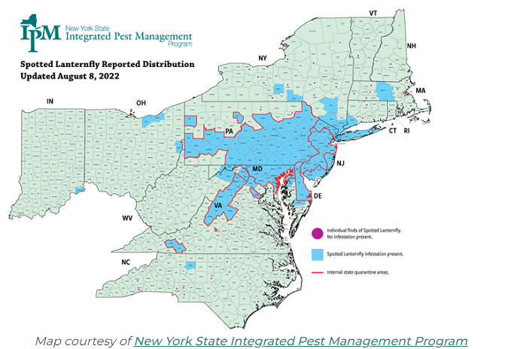
For Michigan, the stakes are incredible high if we lose the battle against these pests. Spotted lanternflies feed on over (70) different variety of trees, numerous fruit trees, grape vines, and hop vines. Their feeding habits wound plants allowing pathogens into the plants thereby infecting them. If these insects take over Michigan, they will wreak havoc on grape and hop vines, apple trees, stone fruit trees, and trees used for lumber. The results can be devastating to Michigan farmers, the state food and agriculture industry, and the lumber industry!
It is interesting to note that spotted lanternflies do not fly very far on their own. They typically spread by hiding on firewood, plants that are shipped for sale, campers, and vehicles. In other words, people are unknowingly the conduit through which these pests are being spread throughout the country!
So what can we do to help? The Michigan Department of Natural Resources recommends the following items to prevent the spread:
- Check your vehicle: Before leaving a parking lot or work site, inspect vehicles for spotted lanternfly eggs or insects. Check doors, sides, bumpers, wheel wells, grills, and roofs. If found, destroy any eggs or insects that you find.
- Park with windows closed: The spotted lanternfly and its nymphs can enter vehicles unsuspectedly.
- Remove and destroy pests: Crush nymphs and adult insects (Spotted lanterflies are not harmful to humans in that they will not sting or bite you). Scrape egg masses into a plastic bag containing had sanitizer or rubbing alcohol to kill them. See image of eggs on a deck below.
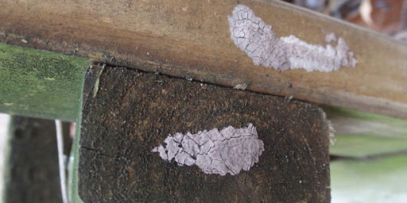
- Remove host trees: Spotted lanternflies prefer the “tree of heaven” (Ailanthus altissima). Try to remove trees from properties to avoid attracting spotted lanternflies.
- Report sightings to Michigan Department of Natural Resources’ “Eyes in the Field” at the following website: https://www2.dnr.state.mi.us/ORS/Survey/38. Photos are necessary to help verify a report and aid in identification.
As I reported in December, you can also contact one of the following organizations and report what you have found:
- Michigan Department of Agriculture and Rural Development: Email MDA-Info@michigan.gov or call the MDARD Customer Service Center at 800-292-3939.
- MSU Plant and Pest Diagnostics: Email pestid@msu.edu or call 517-432-0988.
- Use the Midwest Invasive Species Information Network’s (MISIN) online reporting tool or download the MISIN smartphone app and report from your phone: http://www.misin.msu.edu/tools/apps/ #home.

Written by: Greg Petrosky
Date: August, 2022

